Justin Winfield

CSC 424

Homework 1

April 22, 2018

Problem 2

1. The advantage of Ridge regression is that it’s working on an existing regression model and modifies it by reducing the variance when doing a sum of squares of the coefficients to get it to zero but the disadvantage that it does not usually go to zero. In Lasso, the advantage is able to do variable selection to compute a model and allows the coefficients to shrink to zero by taking the sum of the absolute values of the coefficients. They are different is based on how they calculate the penalty term: in ridge it is the sum of squares of the coefficients while lasso is the sum of the absolute value of the coefficients.
2. Some of the reasons for overfitting is if one or more variables are highly correlated with each other or if the model fits really well on the training dataset but not on the test dataset. One way is to collect more data to update our model or using simple model by “regularizing” the regression model.
3. Multicollinearity is when one or more variables are highly correlated with each other in linear regression. Ways to diagnose it is checking the Variance Inflation Factor and see if that particular variable is greater than 10. If so, we might consider removing it from the equation unless specified otherwise. The other option is to use the different automated procedures such as Backward/Forward/Stepwise selections and verify the best model based on the Cp statistic.

Problem 3

In this article, the team performed 2 PCA, one on the 3 scales (perceived concerns, withholding voice, and speaking up) with different items in each scale and another one on the speaking up items to identify some underlying scale. Their use of PCA was the use of latency theory rather than dimension reduction since they were looking to understand more about the speaking up climate and how that improves patient safety.

In their statistical analysis, they used an orthogonal varimax rotation to maximize the independence of the measured dimensions. For their behavioral analysis, they had 2 principal components where the first one was on perceived concerns and the 2nd one was both speaking up and withholding voice, which are opposites, so the group forced a 3 principal components to keep what they had. In their results, they saw that more healthcare workers (HCWs) were silent than speaking especially when HCWs are no in managerial roles with most of them are consider speaking up safety. In their speaking up climate analysis, they ended up with 3 components, PSS for psychological safety scale, ESS for encouraging environment scale, and RES for resignation scale. In the results, HCWs without managerial roles have lower PSS and ESS when compared HCWs with managerial roles but have higher RES due to barriers towards speaking up. In both analyses, they evaluated the components stability by the Kaiser-Meyer-Olkin measure and the Bartlett test of sphericity.

Problem 4

This article explains how Prevention is a cornerstone of healthcare and how Preventive Healthcare information (PHCI) must be available to all people. With the rise of digital technologies, the study wants to see how PHCI can be leveraged across different social media and network. They're applying factor analysis by reducing the 28 social media variables to several groups that can explain the variables. In the analysis, they confirmed their factorability by using the Kaiser-Meyer-Olkin measure and the Bartlett test of sphericity. They ended up with 3 factors, Hybrid Electronic Sites, Contemporary social media platforms and network and traditional digital sources. Hybrid contains websites from hospitals and employers with wellbeing healthcare information on their websites with Web 2.0 standards, Contemporary means social media platforms like Facebook, Twitter, YouTube, and others, and Traditional which refers to WebMD and Wiki. From there, they used ANOVA to examine the demographics for each of the factors. They concluded that young (19-24) African Americans are more likely to view these types of social media platforms and the author draws conclusions on how, in general, they receive lower-quality of interpersonal care and rely less on direct clinical are professionals.

Problem 5

1. To explain 100% of the total variation of the data, we will need to use all 25 components. Based on the scree plot from PCA the number of components I would use would be either 5 because I believe the knee bends around that component.

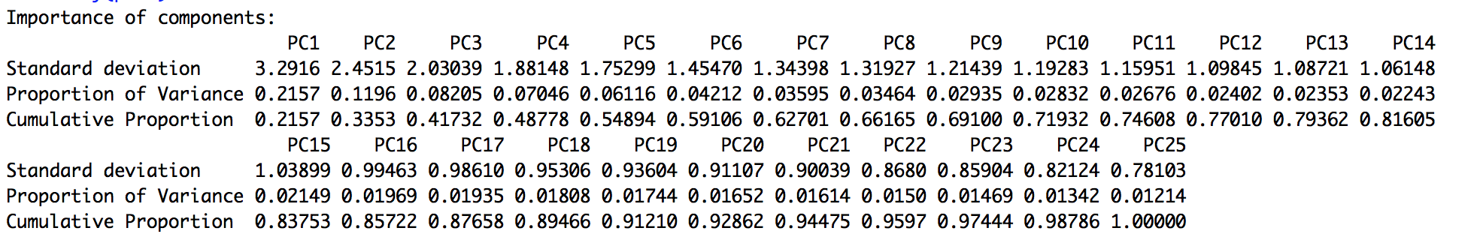



Below are the following formula for each of the components:

RC2 = N1\*0.806 + N2\*0.794+N3 \*0.794+N4 \*0.649+N5\*0.631

This component explores the different emotions

RC1 = E1\*0.680-E2\*0.722 +E3\*0.626+E4\*0.700+E5\*0.586

This component details about being an introvert

RC3 = C1\*0.654 +C2\*0.738 +C3\*0.679-C4\*0.692-C5\*0.627

This component shows characteristics of a hard-worker/perfectionist

RC5 = -A1\*0.63+A2\*0.716+A3\*0.688+A4\*0.53+A5\*0.572

This component shows how personable one person is

RC4 = O1\*0.598-O2\*0.606+O3\*0.64-O5\*0.677+O4\*0.494

This component explores the creativity/imagination

The names I would give for these components would be the following

RC2 = Emotional

RC1 = Introversion

RC3 = Hardworking

RC5 = Personable

RC4 = Creativity

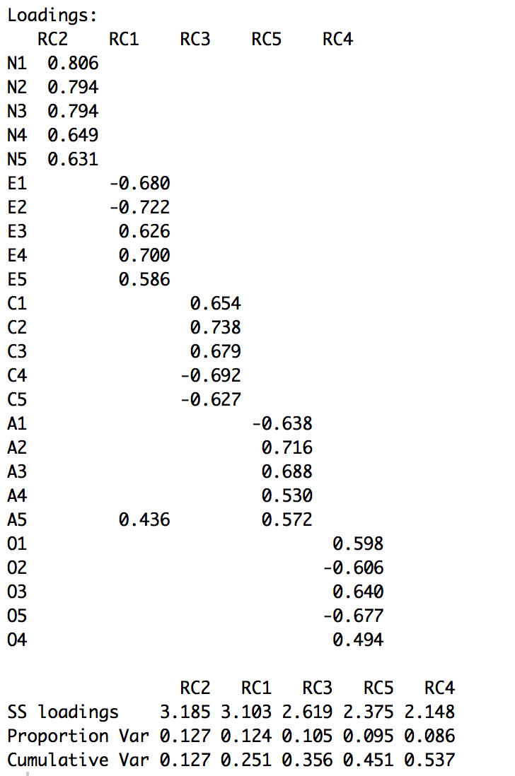

1. 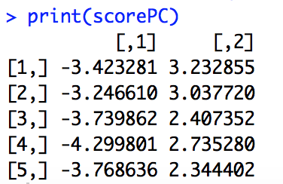
2. Comparing the results from B, it appears to be similar apart from the items are in different locations for some and there’s one item where are no values in the factor analysis but there’s one from PCA.

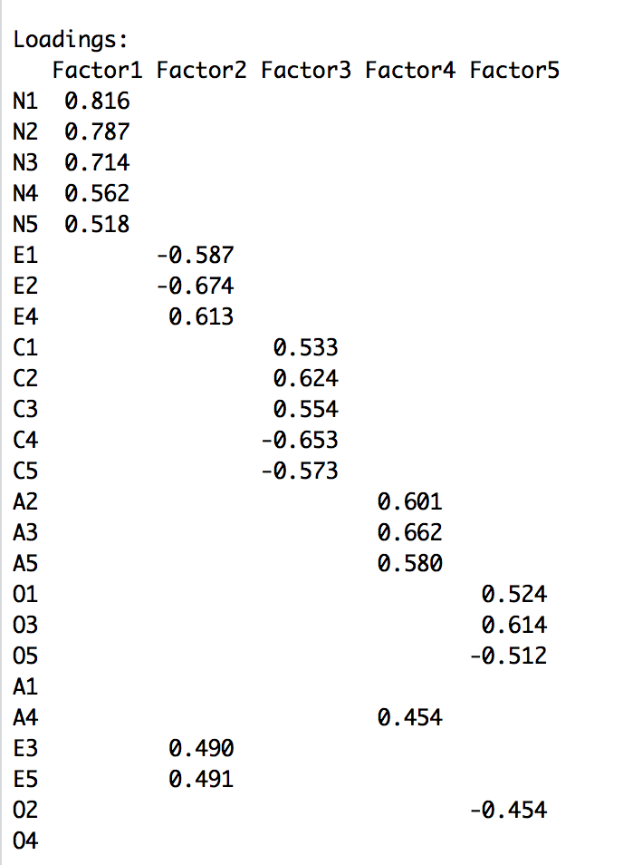

Problem 6

1. The first principal component accounts for all of the variance because we’re not using the same unit of measure (percent vs dollars). We will need to normalize the data in order to see how much of the variance is being accounted for all of the PCs

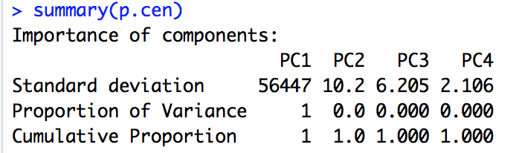

1. By dividing the variable MedianHomeValue by 100,000 this would reduce the values and put the scaling relatively the same with the other variables in the dataset
2. Looking at the summary and scree plot, the results in B still has a high variance scale due to the MedianHomeValue but after running PCA with the correlation matrix, the scale has been significantly reduced



1. Looking at the correlation matrix we that Professional and MedianHomeVal have a high correlation with each other at 0.69, which suggest there might be multicollinearity.



Problem 7

We started off looking at the correlation of the dataset. The initial correlation shows how some variables have high correlation with each other while there are some with weak correlation. With the goal of finding variables that are highly correlated, we will remove the weak correlated variables



Below is the correlation matrix after removing all the weak correlated variables.



Once completing the correlation, a Principal Component Analysis was run. Since we’re dealing with different likert scales, we will use the correlation matrix to normalize the data. After running the analysis with the summary and scree plot, it looks like we’re looking at 3 components, where RC1 = Doctor’s Medical Expertise, RC2 = Health Info Sources, RC3 = General Health.



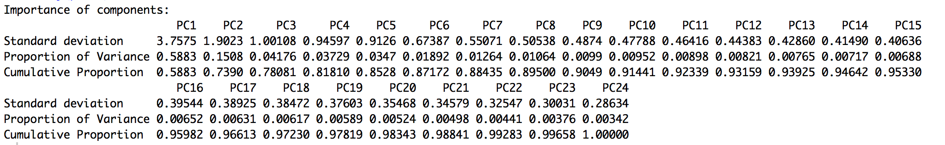

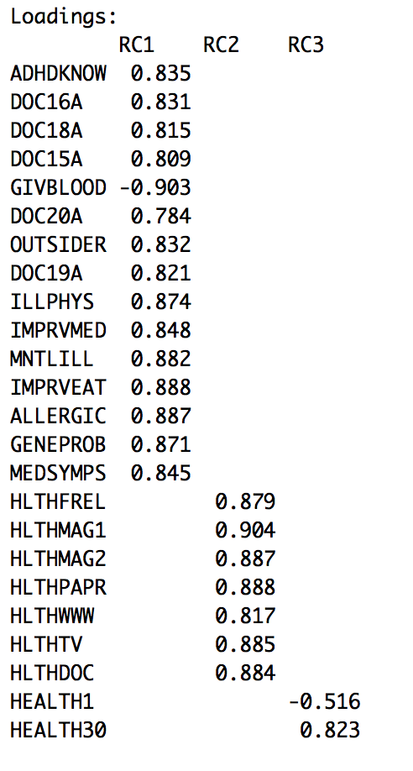

After reviewing the Principal Component Analysis, a Factor Analysis was performed to see if our PCA is aligned with the components

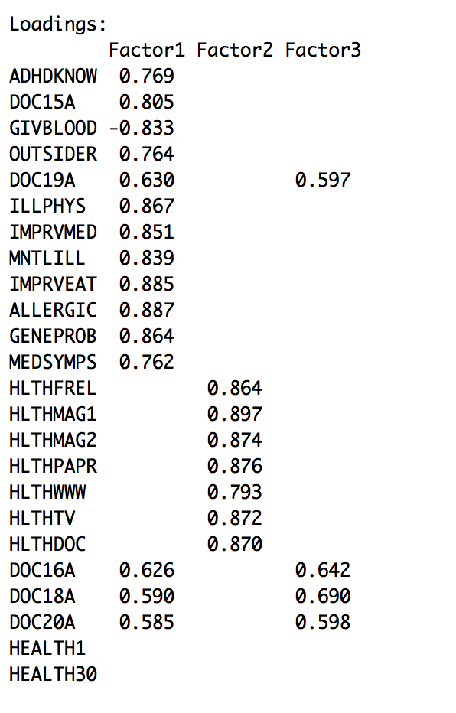

There are some differences between CFA and PCA where there are several items in both Factors 1 and 3. With the higher loading values found in Factor 3, that will be assigned to that factor instead of Factor 1 but, in general, this confirms our PCA.